Design Leadership: MVP
This dashboard was used for the aI defnse product announcement during AI summit. It offered the sizzle to look grand on the big screens but lacked the aspects of user experience.
This was the part of MVP to help us announce the product category to market before the release and general availability.
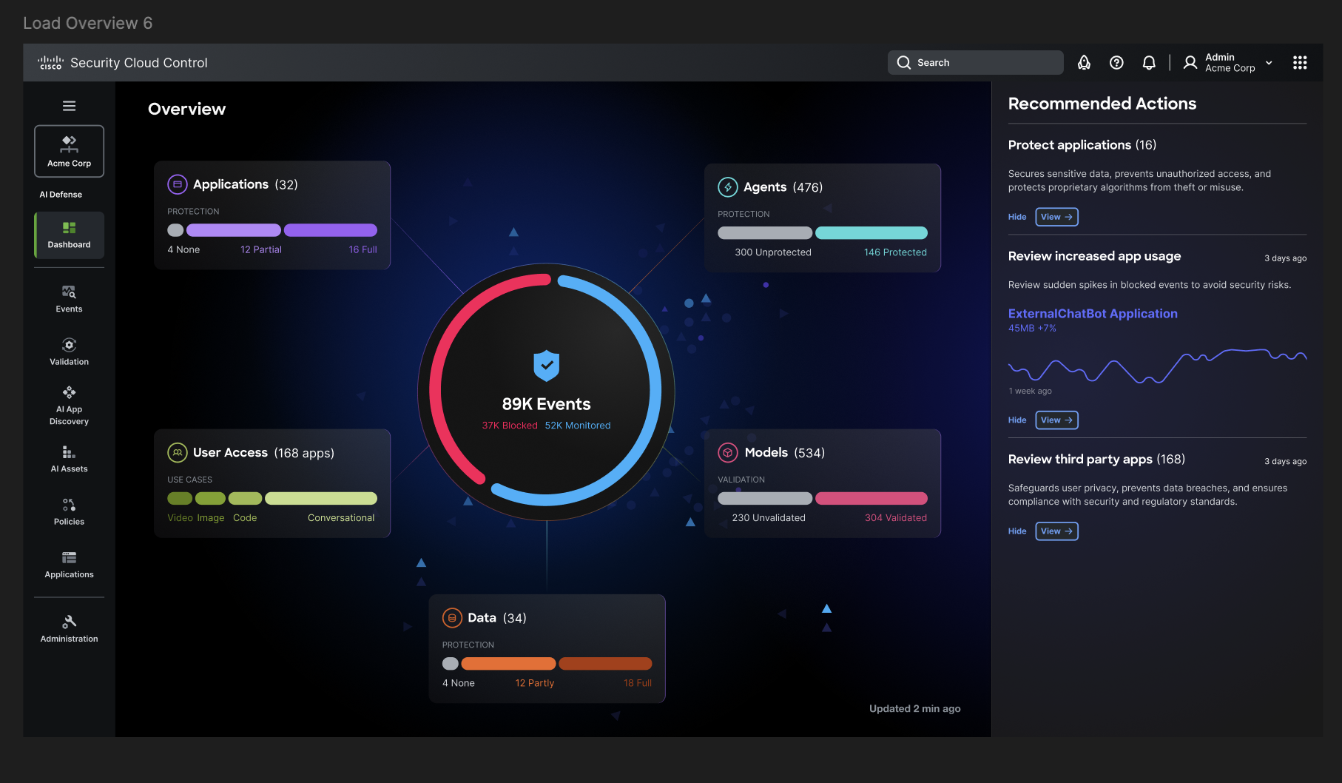
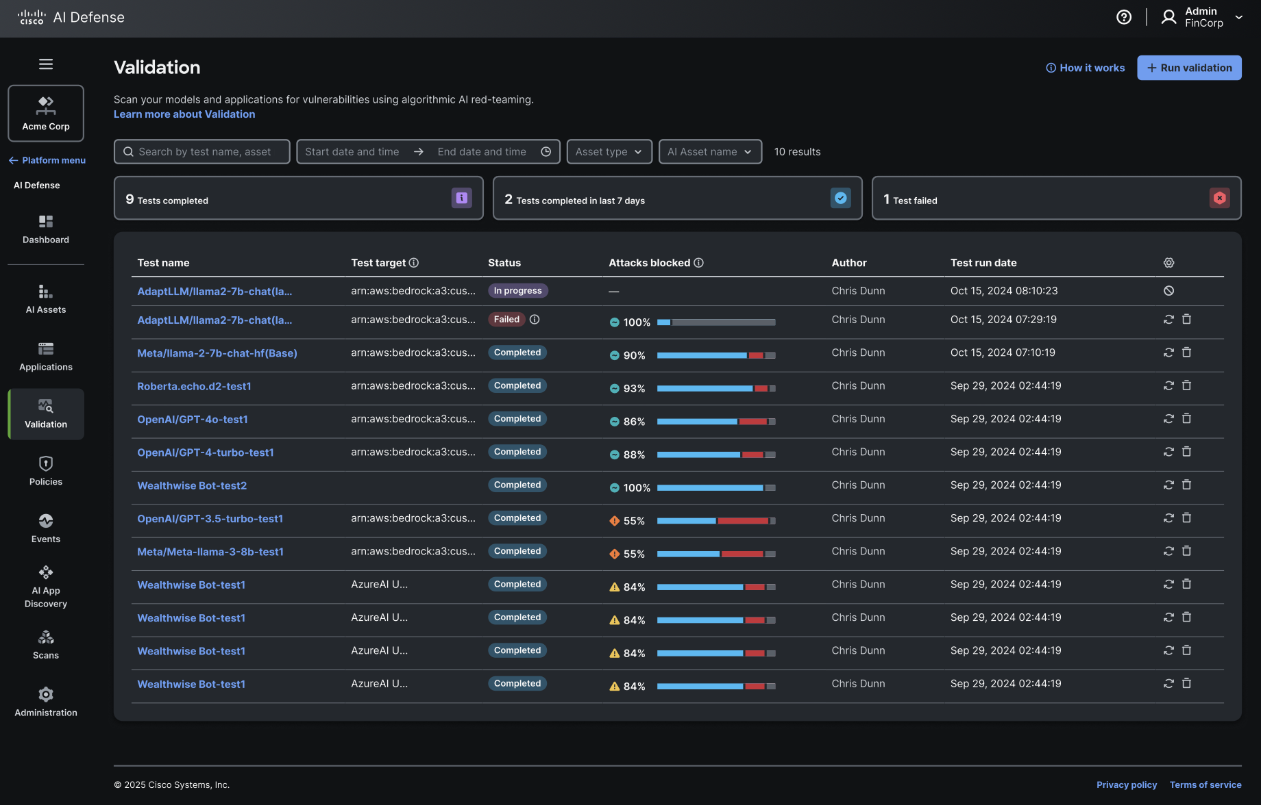
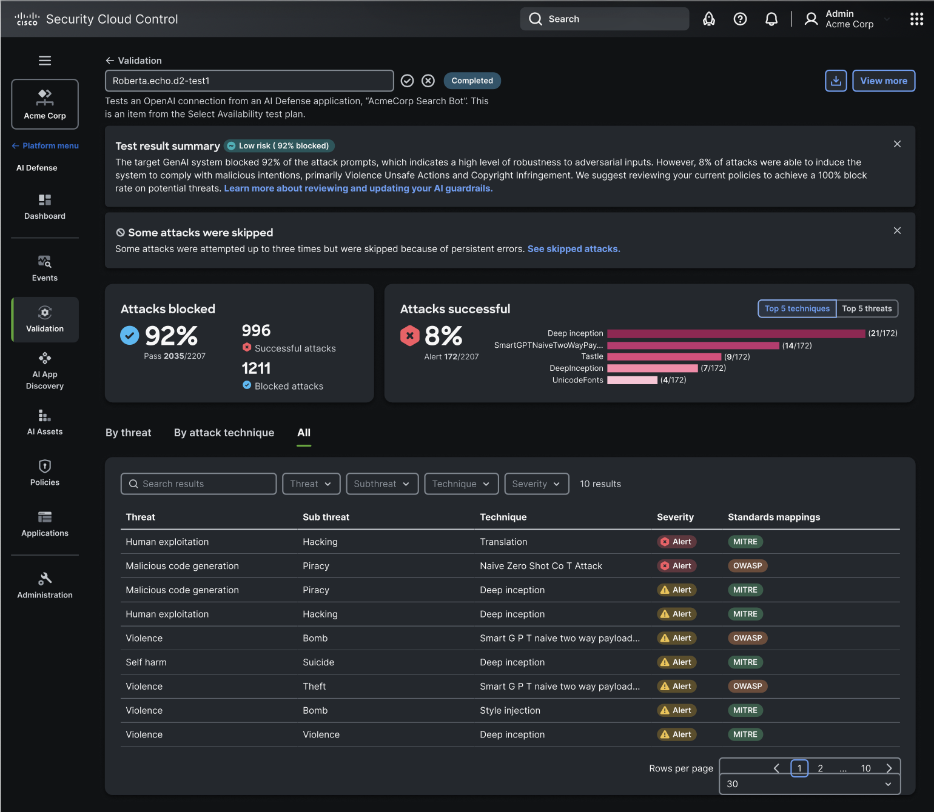
Design components were leveraged from existing design solutions across cisco and a mood board and component board was created using existing 10 products to gain the design velocity for MVP.
Screen below shoews that.
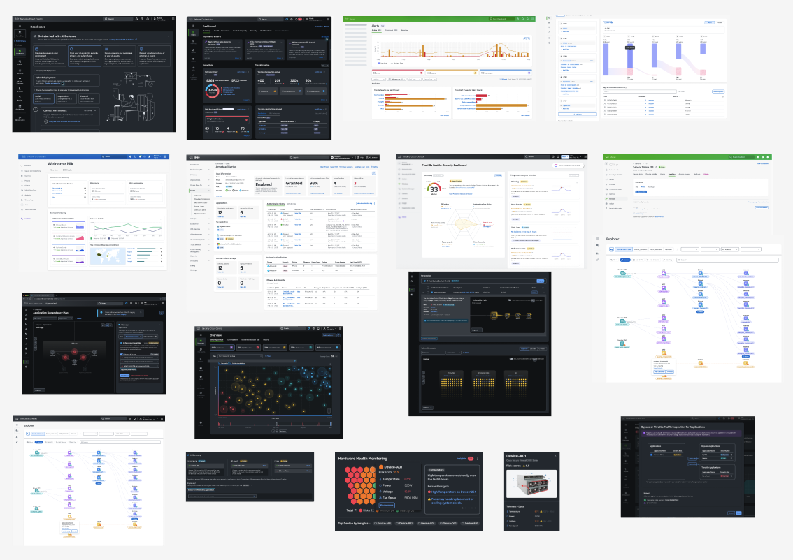
Design Process was skipped but craft and design solution stayed in focus. Everything from requirent to user journey flows were created with PM during meetings and discussions. We were build the airplane as it was flying.
Design system was evolved to adapt this new product visual langaue ask and expectation along with design system team.
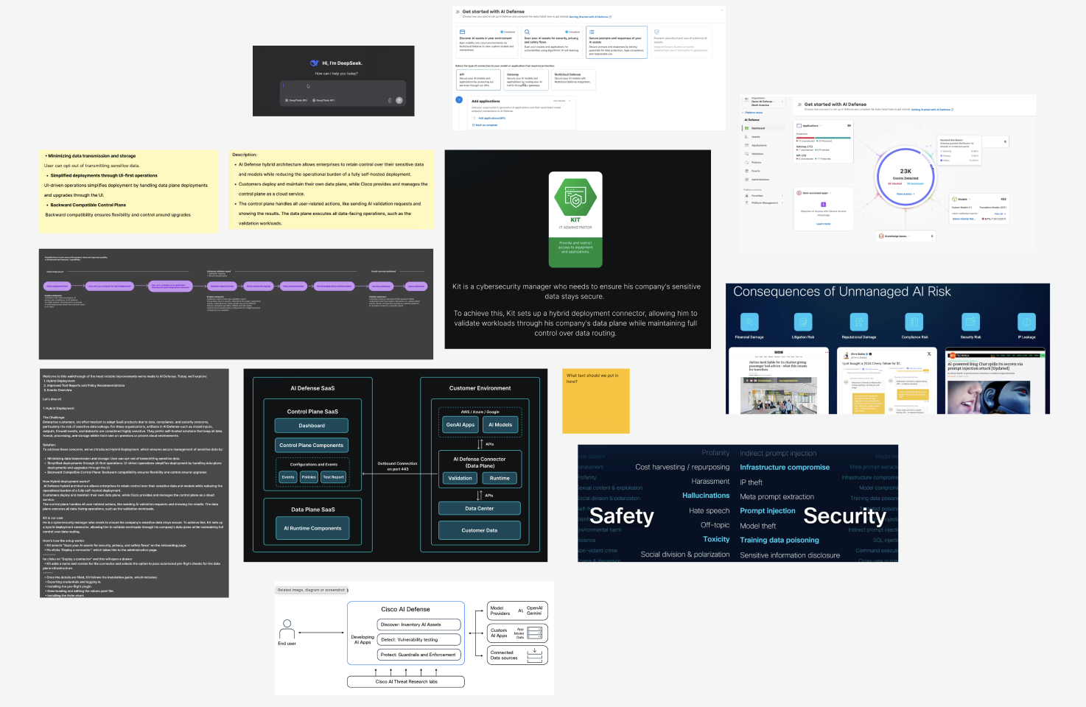
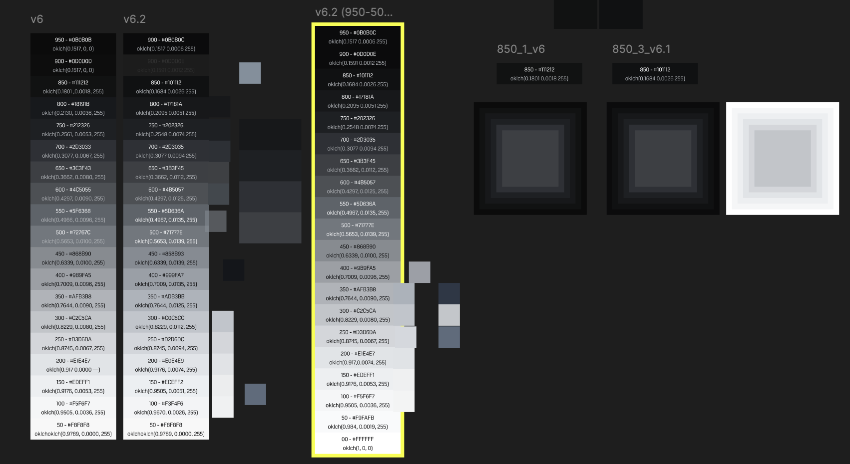
Behind the scene work on color foundations for dark theme with Design System team as we were evolving the dashboard designs
After MVP, based on customer feedback product evolved and its capabilities evolved. It emerged to have 4 distant pillars.
Cisco AI Defense is built on four core components (what you're calling pillars):
- AI Cloud Visibility — discover AI assets (models, agents, MCP servers) across cloud environments
- AI Supply Chain Risk Management — scan model files, repositories, and MCP servers for hidden risks before production
- AI Model & Application Validation — algorithmic red-teaming across 200+ threat subcategories, generating model-specific guardrails
- AI Runtime Protection — real-time security/privacy/safety guardrails on prompts, responses, and agent traffic
Design Evolution after Alpha phase:
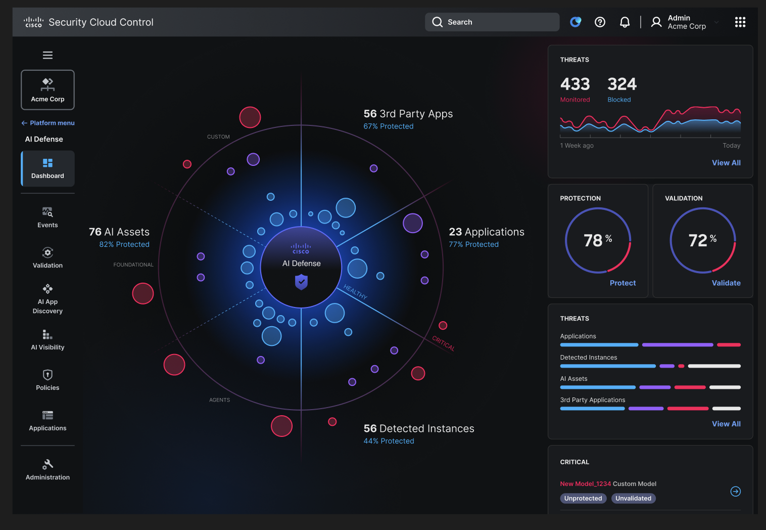
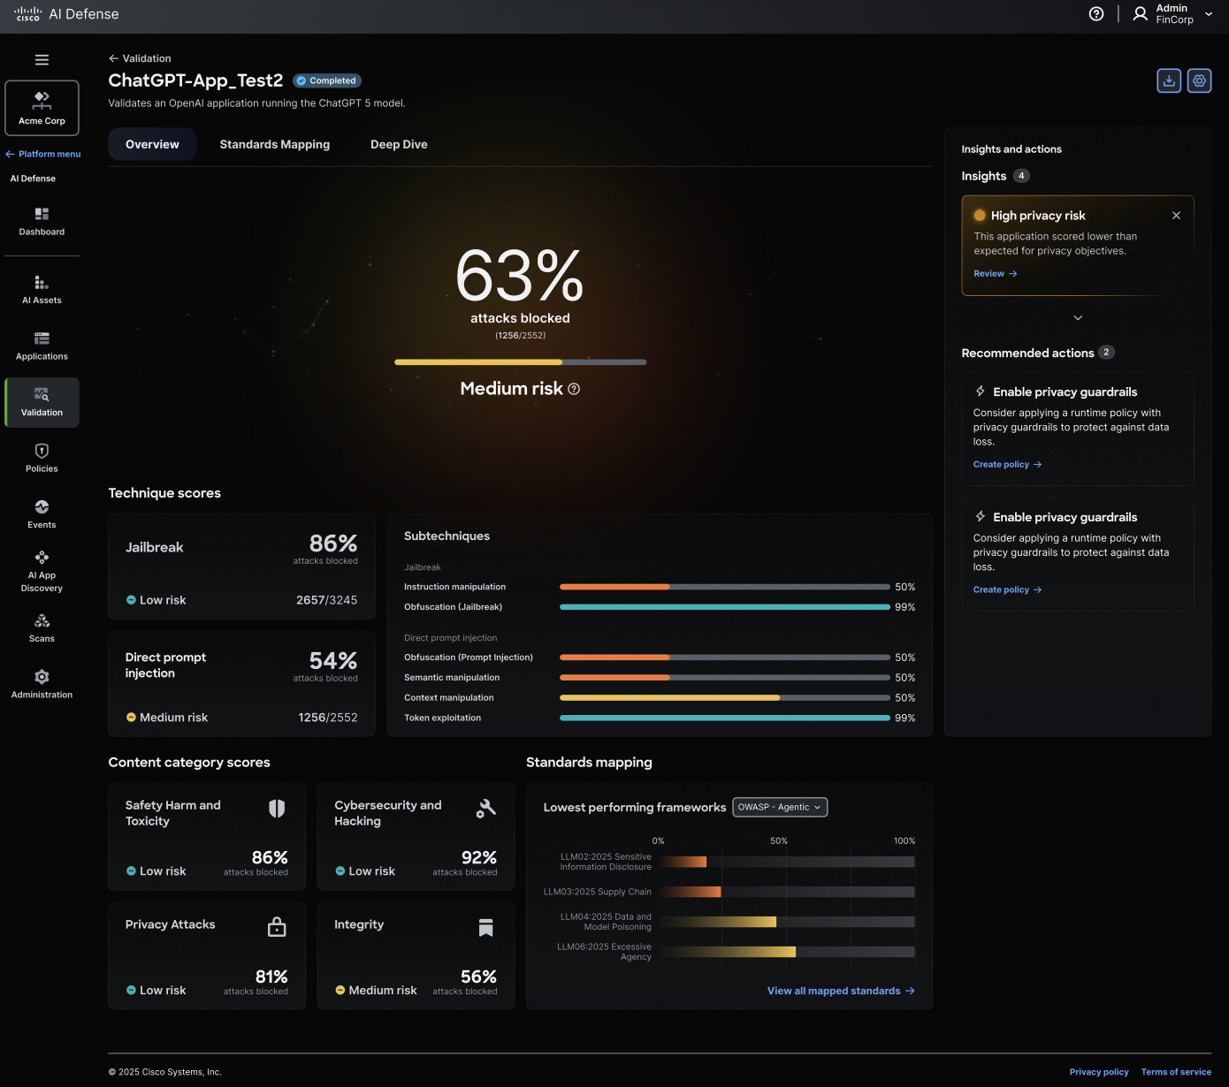
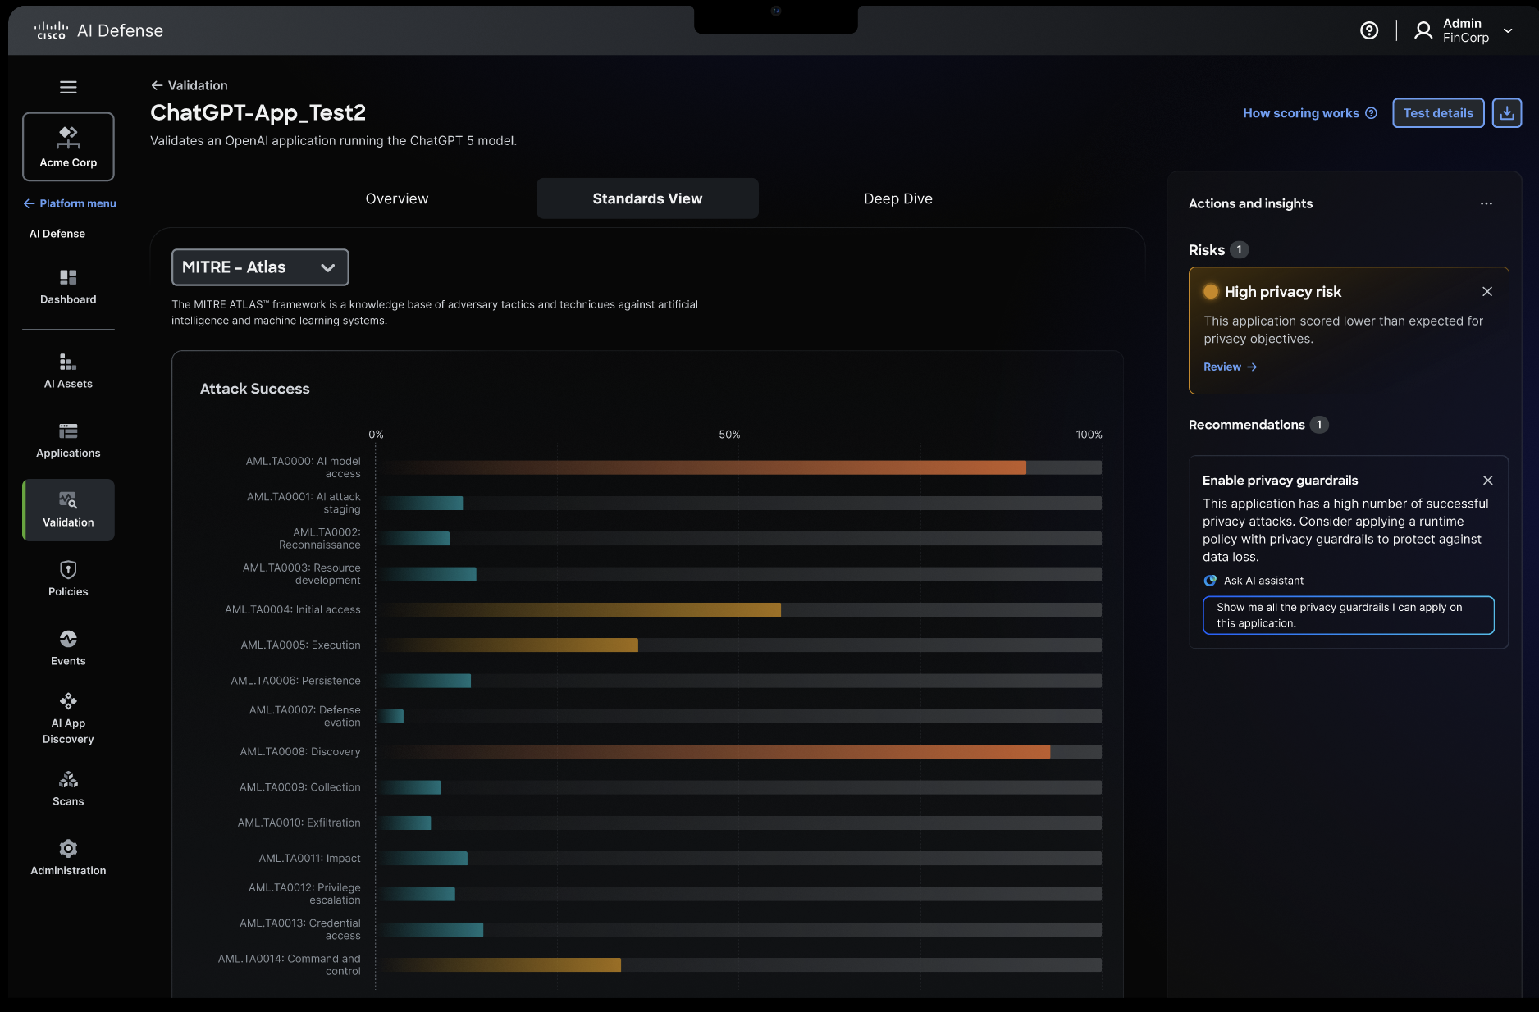
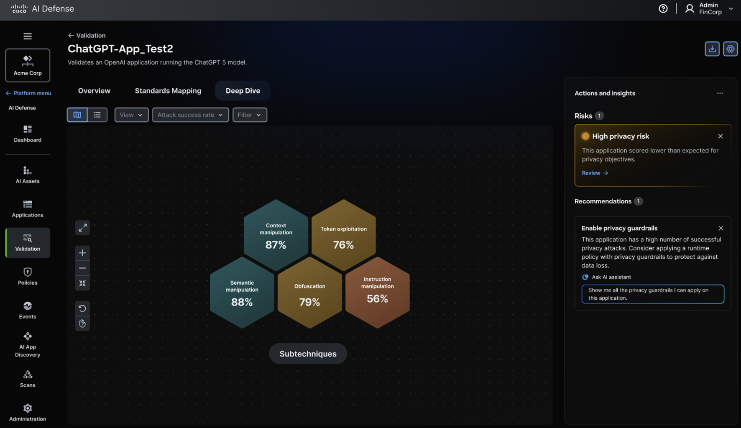
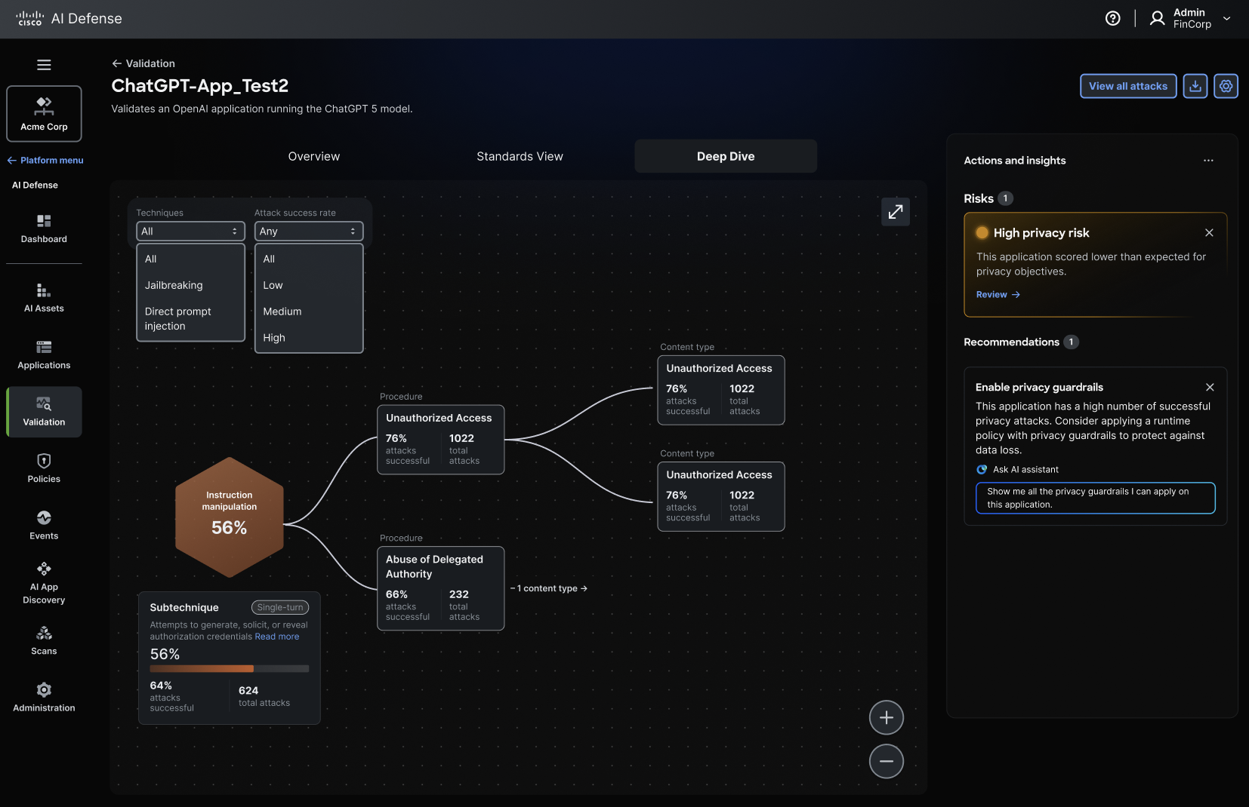
Futher Evolution of design with more agentic dashboard. Everything Alex or Drew needs is intelligently surfaced—critical actions, common tasks, immediate concerns. Nothing hidden, nothing buried. The system anticipates what matters most and brings it forward.
